WOMEN ARE NOT JUST OVENS!

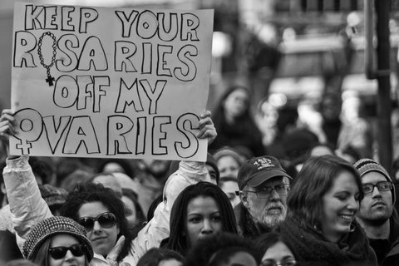

We believe that women have the right to decide what our bodies go through. If we don't want to have a baby, or because of circumstances, we can't have a baby, we may decide to have an abortion. Nobody LIKES to have an abortion, but for the 1 in 3 women who decide they NEED one, we are thankful that we can access one in the UK. Women in Ireland or Poland are not so lucky.

But we can't take this access to abortion for granted. We are seeing increasing numbers of religious right-wingers standing outside clinics, trying to stop women from going inside. They peddle lies and use various manipulative and highly organised tactics to try and stop women from going into the clinic. If they are anti-abortion, fine. Everyone is entitled to their opinion. But they don't have a god-given right to target and harass women as they enter the clinic. In Blackfriars, they were even filming people going in and out, including staff.
This is unacceptable!

Today a religious group is marching from their church to the abortion clinic in Stratford. We are organising a demonstration here today to make them know that what they're doing is NOT OKAY! If they think they can spread their anti-women views freely, they can think again! Join us in our action or get in touch with us for more information.

www.feministfightback.org.uk
feminist.fightback@gmail.com

